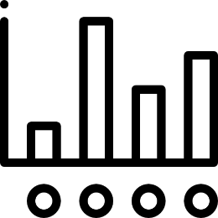



Statistical Computing

and

Simulation HW3

授課教授: 余清祥教授

學生: 統計碩一 106354003 林健宏

統計碩一 106354012 曹立諭

**目錄**

# Question 01. 2

# Question 02. 3

# Question 03. 4

# Question 04. 5

# Question 05. 6

❒ 附錄 (R code) 7

1. 7

2. 8

3. 9

4. 10

5. 11



Experiment with as many variance reduction techniques as you can think of to apply the problem of evaluating $P\left(X>1\right)for X∼Cauchy$.



Hammersley and Handscomb (1964) used the integration of $ $θ=\int_{0}^{1}{\frac{e^{x}-1}{e-1}}dx on (0,1)$

as a test problem of variance reduction techniques (which is about 0.4180233).

Achieve as large a variance reduction as you can. (They achieved 4 million.)



Let $X_{i},i=1,2,3,4,5$ be independent exponential random variables each with mean 1,

and consider the quantity $\theta$ defined by $θ=P(\sum_{i=1}^{5}{iX_{i}}≥21.6)$.

Propose at least three simulation methods to estimate $\theta$ and compare their variances.



First, simulate 100 observations from $Beta(2,3)$ and then use 3 density estimating methods to smooth the observations. You need to specify the parameters in the smoothing methods, and compare the results.



Let $x$ be 100 equally spaced points on $[0,2π]$ and let $y_{i}={sinx}_{i}+ϵ_{i}$ with $ϵ_{i}∼N(0,0.09)$.

Apply at least 3 linear smoothers and compare the differences, with respect to mean squares error

(i.e., ${bias}^{2}$ and variance) from 1,000 simulation runs.

* 附錄 (R code)

Github : <https://github.com/CaoCharles/Statistical-Computing-and-Simulation-HW3>

R Markdown :